**EXPERIMENT 1:**

**To Perform Various Commands in sql in oracle:**

•Find the name, street address, and cities of residence of all employees who work for FBC and earn more than $10,000.

select e.empname, e.street, e.city from Employee e join Works w on w.empname = e.empname where w.compname = 'FBC' and salary > 10000;



• Find all employees who live in the same cities.  
select city, count(empname) from Employee group by city;

•Find the company with the smallest pay roll

•Find the average salary for all employees.

select avg(salary) from Works;



• Find the Employee who receives the lowest pay.  
select * from Works where salary in (select min(salary) from Works);

•Find the Maximum salary of employee in particular company.

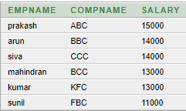

•Sort the employee names according to their salary.

select empname, salary from Works order by salary;

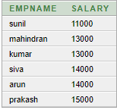

•Find the Employee name that who works under same manager.

select empname, managername from Manager;

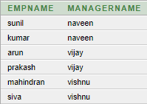

•Insert a new employee to a database, and update the table.

insert into Employee(empname, street, city) values ('suresh', 'west', 'bengal');

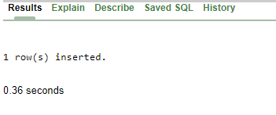

•Give the names of the employees living in the same city where their company is located.

select e.empname from Employee e join Works w on e.empname = w.empname join Company c on w.compname = c.compname and e.city = c.city;

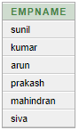

•Give the name of manager and salary of employee SUNIL.

select m.empname, w.salary, m.managername from Manager m join Works w on w.empname = m.empname where m.empname = 'sunil';

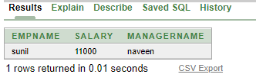

**RESULT:**

**EXPERIMENT 2**

**STAR SCHEMA:**

create table time(time_key varchar(20) primary key, day varchar(20), day_of_the_week varchar(20), month varchar(20), quarter varchar(20), year varchar(20));

create table item(item_key varchar(20) primary key, item_name varchar(20), brand varchar(45), type varchar(20), supplier_type varchar(20), supplier_key int);

insert into item values ('01', 'LG TV', 'LG', 'TV', 'B2B', '01');

insert into item values ('02', 'Whirlpool 240', 'Whirlpool', 'TV', 'B2B', '02');

insert into item values ('03', 'Xiomi mi TV', 'mi', 'TV', 'B2B', '03');

insert into item values ('04', 'Sony', 'Sony', 'washing machine', 'B2B', '04');

insert into item values ('05', 'Samsung 253', 'Samsung', 'washing machine', 'B2C', '05');

select * from item;

create table location(location_key varchar(20) primary key, street varchar(45), city varchar(20), province_or_state varchar(20), country varchar(20), city_key int);

insert into location values('01', 'east street', 'madurai', 'tamilnadu', 'india', '01');

insert into location values('02', 'west street', 'coimbatore', 'tamilnadu', 'india', '02');

insert into location values('03', 'north street', 'chennai', 'tamilnadu', 'india', '03');

insert into location values('04', 'south street', 'kanyakumari', 'tamilnadu', 'india', '04');

insert into location values('05', 'east street', 'thirunelveli', 'tamilnadu', 'india', '05');

select * from location;

create table branch(branch_key varchar(20) primary key, branch_name varchar(45), branch_type varchar(20));

insert into branch values('01', 'vasanth&co', 'Home appliances');

insert into branch values('02', 'vivek&co', 'appliances');

insert into branch values('03', 'PR&co', 'Electronics');

insert into branch values('04', 'Mraman&co', 'Home appliances');

insert into branch values('05', 'nataraj&co', 'appliances');

select * from branch;

create table salesfacttable(time_key varchar(20), item_key varchar(20), location_key varchar(20), branch_key varchar(20), dollars_sold varchar(20), units_sold varchar(20));

**SNOWFLAKE SCHEMA:**

create table supplier(supplier_key int primary key, supplier_type varchar(45));

insert into supplier values('01', 'B2B');

insert into supplier values('02', 'B2B');

insert into supplier values('03', 'B2B');

insert into supplier values('04', 'B2B');

insert into supplier values('05', 'B2C');

create table city(city_key int primary key, city varchar(20), province_or_state varchar(20), country varchar(20));

insert into city values('01', 'madurai', 'tamilnadu', 'india');

insert into city values('02', 'coimbatore', 'tamilnadu', 'india');

insert into city values('03', 'chennai', 'tamilnadu', 'india');

insert into city values('04', 'kanyakumari', 'tamilnadu', 'india');

insert into city values('05', 'thirunelveli', 'tamilnadu', 'india');

create table shippingfacttable(item_key int, time_key int, shipper_key int,from_location varchar(45), to_location varchar(45), dollar_cost varchar(45), units_shipped varchar(45));

create table shipper(shipper_key int primary key, shipper_name varchar(45), location_key varchar(20), shipper_type varchar(20));

insert into shipper values('01', 'adhi', '01', 'B2B');

insert into shipper values('02', 'siva', '02', 'B2B');

insert into shipper values('03', 'arun', '03', 'B2B');

insert into shipper values('04', 'prakash', '04', 'B2B');

insert into shipper values('05', 'ajay', '05', 'B2C');

create table time(time_key varchar(20) primary key, day varchar(20), day_of_the_week varchar(20), month varchar(20), quarter varchar(20), year varchar(20));

insert into time values('01', '11-06-1997', 'FRIDAY', 'JUNE', '2', '1997');

insert into time values('02', '07-11-1999', 'SUNDAY', 'NOVEMBER', '4', '1999');

insert into time values('03', '09-02-1997', 'WEDNESDAY', 'FEBRUARY', '1', '1997');

insert into time values('04', '27-07-2012', 'FRIDAY', 'JULY', '3', '2012');

insert into time values('05', '05-09-2012', 'SUNDAY', 'SEPTEMBER', '3', '2012');

insert into salesfacttable values('01','01','01','01','700','7')

insert into salesfacttable values('02','02','02','02','800','8')

insert into salesfacttable values('03','03','03','03','900','9')

insert into salesfacttable values('04','04','04','04','1000','10')

insert into salesfacttable values('05','05','05','05','1100','11')

select * from salesfacttable;

**RESULT:**

**Experiment-3**

create table employee_details(id integer primary key, name varchar2(20), job varchar2(20), salary number(10));

insert into employee_details values(7369, 'kumar','clerk', 20000);

insert into employee_details values(7566, ' ram', 'manager ' ,40000);

insert into employee_details values(7654, ' surya', 'salesman ' ,25000);

insert into employee_details values(7499, ' ajay', 'salesman' ,30000);

insert into employee_details values(7521, ' prakash', 'salesman' ,35000);

insert into employee_details values(7788, ' arun', 'analyst' ,40000);

insert into employee_details values(7839, ' siva', 'president' ,80000);

ROLL-UP:

select name, id , job, sum(salary) as salary from employee_details group by rollup(name, id , job);

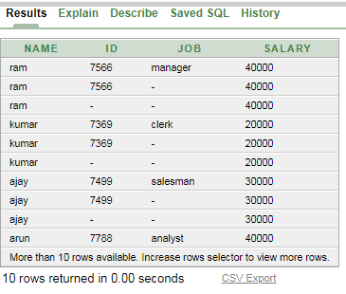

DRILL-DOWN:

select name, job, salary from employee_details;

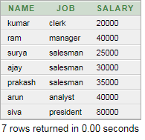

SLICE:

select *from employee_details where salary<40000;

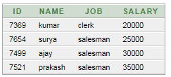

DICE:

select name, job , sum(salary) as "salary" from Employee_details where (salary > 20000 and job = 'salesman') group by name , job order by name asc;

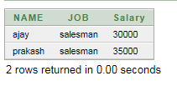

PIVOT:

select salary, max(decode(salary,'40000',name))ANALYST, max(decode(salary,'20000',name))CLERK,max(decode(salary,'40000',name))MANAGER ,max(decode(salary,'25000',name,'30000',name,'35000',name))Salesman, max(decode(salary,'80000',name))President from (select job,salary,name from Employee_details) group by salary order by salary;

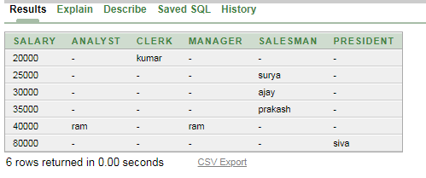

**RESULT:**